Dylan Gallup

CS260: Object Oriented Programming

Professor Tevis Boulware

Week 3 Assignment

Sources: Professor Tevis Boulware

**Program Form**

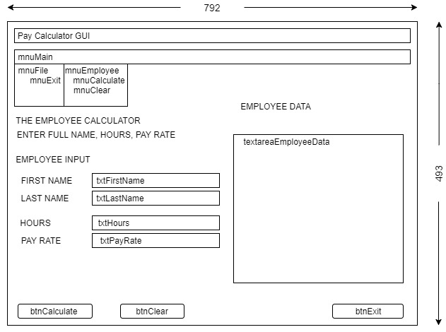

**Control/Event Table**

|  |  |  |  |  |
| --- | --- | --- | --- | --- |
| **CONTROL** | **TYPE** | **TEXT** | **EVENT** | **OPERATION** |
| btnCalculate | JButton | Calculate | actionListener | Instantiates Employee Data and displays the result of the calculation |
| btnClear | JButton | Clear | actionListener | Clears the textArea and input fields |
| btnExit | JButton | Exit | actionListener | Closes the Program, asks the user first |
| mnuExit | Menu Item | Exit | actionListener | Closes the Program asks the user first |
| mnuCalculate | Menu Item | Calculate | actionListener | Instantiates Employee Data and displays the result of the calculation |
| mnuClear | Menu Item | Clear | actionListener | Clears the textArea and input fields |
| txtFirstName | JTextField |  | actionListener | Gets user input and validates |
| txtLastName | JTextField |  | actionListener | Gets user input and validates |
| txtHours | JTextField |  | actionListener | Gets user input and validates |
| txtPayRate | JTextField |  | actionListener | Gets user input and validates |

Method Specification Form

|  |  |  |  |  |
| --- | --- | --- | --- | --- |
| **Method Name**: calculateData | | | **Class Name**: PayCalculatorGUI | |
| **Description:**  Function validates all the input fields and returns the gross pay results into a string. | | | | |
| **Triggers/Events**:  Jbutton “Calculate” / Menu Item “Calculate” | | | | |
| **Return Type:** void | | | | |
| **Input Parameters** | **Data Type** | **Valid Value Range** | | **Description** |
|  |  |  | |  |
|  |  |  | |  |
|  |  |  | |  |
|  |  |  | |  |
| **Output Parameters** | **Data Type** | **Valid Value Range** | | **Description** |
|  |  |  | |  |
|  |  |  | |  |
|  |  |  | |  |
|  |  |  | |  |
| **Pseudocode:**  if(txtFirstName is not NULL) employee.setFirstName and keep going  if(txtLastName is not NULL) employee.setLastName and keep going  if(txtHoursWorked is valid) employee.setHoursWorked and keep going  if(txtPayRate is valid) employee.setPayRate and keep going  textareaEmployeeData.setText.setText(employee.toString()); | | | | |

**Test Cases**

Test Case Scenarios

|  |  |  |  |  |  |
| --- | --- | --- | --- | --- | --- |
| **#** | **Purpose** | **Input Values** | **Expected Results** | **Pass/Fail** | **Comments** |
|  | Check bounds | All valid inputs except  txtFirstName = NULL | Error Prompt to appear | **Pass** |  |
|  | Check bounds | All valid inputs except txtLastName = NULL | Error Prompt to appear | **Pass** |  |
|  | Check bounds | All valid inputs except  TxtHours = -1 | Error Prompt to appear | **Pass** |  |
|  | Check bounds | All valid inputs except  txtHours = 76 | Error Prompt to appear | **Pass** |  |
|  | Check bounds | All valid inputs except  txtPayRate = 7.00 | Error Prompt to appear | **Pass** |  |
|  | Check bounds | All valid inputs except  txtPayRate = 66.00 | Error Prompt to appear | **Pass** |  |
|  | Check Jbutton: Calculate | All valid inputs | Prints out Employee Data | **Pass** | Proves that program works to satisfaction |
|  | Check Menu Item: Calculate | All valid inputs | Prints out Employee Data | **Pass** | Proves that program works to satisfaction |
|  | Check Jbutton: Clear | Input in all text fields | Clears all text fields | **Pass** |  |
|  | Check Menu Item: Clear | Input in all text fields | Clears all text fields | **Pass** |  |
|  | Check Jbutton: Exit | Click on Jbutton | Prompt to ask user to exit and closes program | **Pass** |  |
|  | Check Menu Item: Exit | Click on Menu Item | Prompt to ask user to exit and closes program | **Pass** |  |